Practice 2A.1- Graphing Absolute Value Functions Name: ______________________

For problems 1-6, given the transformed absolute value graph, provide the verbal description, function notation description and the equation.

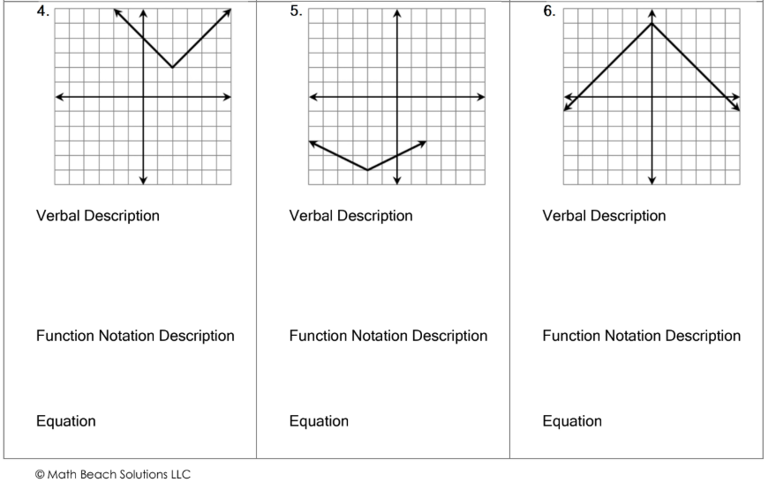
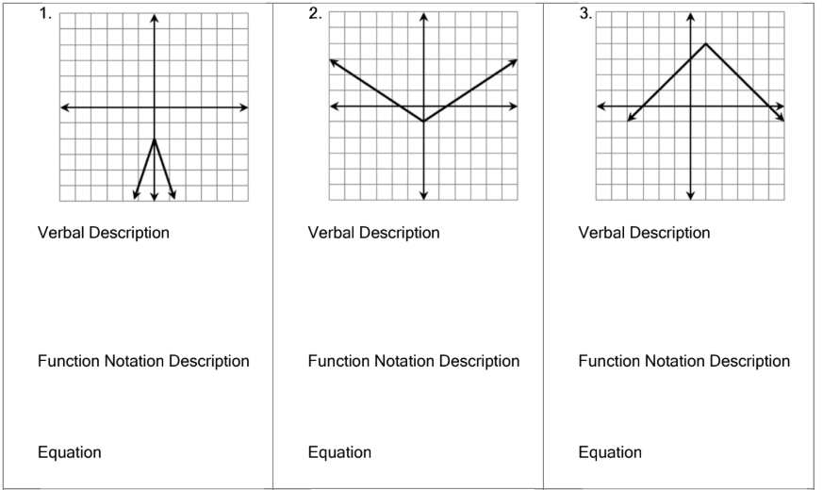

For problems 7-12, given the verbal description, write the equation.
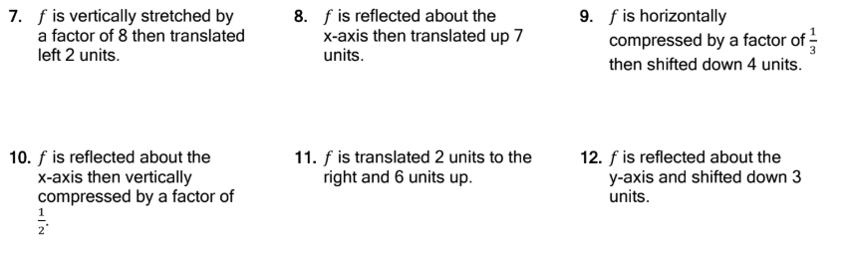

For problems 13-17, given the equation, graph and provide all information.

13.
Equation: $f(x)= |-2x|+3$ | Domain:
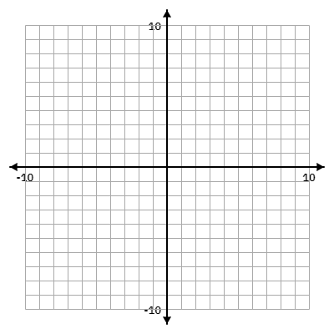 | Range:
X-int:

Y-int:

 | Vertex:
 | Max/Min:
Verbal Description:

Function Notation Description:

14.

Equation: $f(x)= -|x+2|-1$ | Domain:
 | Range:
X-int:

Y-int:

 | Vertex:
 | Max/Min:
Verbal Description:

Function Notation Description:

15.

Equation: $f(x)= -2|x-3|-4$ | Domain:
 | Range:
X-int:

Y-int:

 | Vertex:
 | Max/Min:
Verbal Description:

Function Notation Description:

16.

Equation: $f(x)=\frac{1}{5}\left|x\right|-3$ | Domain:
 | Range:
X-int:

Y-int:

 | Vertex:
 | Max/Min:
Verbal Description:

Function Notation Description:

17.

Equation:$f(x)=-\frac{3}{4}\left|x+1\right|+7$ | Domain:
 | Range:
X-int:

Y-int:

 | Vertex:
 | Max/Min:
Verbal Description:

Function Notation Description:

